**Grep Assignment**

**Mandatory**

1. Use any .c file. Using grep command extract and display
2. all lines beginning with #include with line numbers
3. display all lines which do not begin with #include
4. display the line number of main()
5. extract all lines containing characters of opening and closing parathesis {(,))

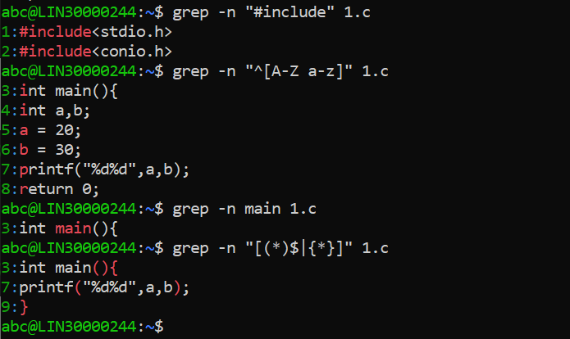

1. Perform the above operations on a set of *.c files

